

INFORMATION TECHNOLOGY
Paper Two
11 November 2013

KZN – DEPARTMENT OF EDUCATION

GRADE 10

MARKS: 150 TIME: 2 hours

INSTRUCTIONS AND INFORMATION:

- This paper consists of 5 questions and 6 pages of print.
- Answer ALL questions and write neatly.
- Number your answers exactly as the questions are numbered.

SUGGESTED TIME REQUIRED TO ANSWER THIS QUESTION PAPER

Question | Subject | Marks | Time in Minutes
1 | MULTIPLE CHOICE QUESTIONS | 10 | 10
2 | HARDWARE & SOFTWARE | 33 | 38
3 | SOCIAL IMPLICATIONS | 30 | 25
4 | PROGRAMMING & SOFTWARE DEVELOPMENT | 29 | 30
5 | INTEGRATED SCENARIO | 19 | 25

QUESTION 1: MULTIPLE CHOICE QUESTIONS (10 MARKS)
Choose the appropriate alternative

1.1 Which type of the following technologies allows telephone calls to be made over the internet?
A SMTP
B VOIP
C HTTP
D FTP

1.2 Which of the following is not a typical example of a software program?
A Spam
B Norton’s Antivirus
C Internet Explorer
D MS Paint

1.3 Which one of the following file extensions does not logically belong with the other three options?
A .JPG
B .MP3
C .BMP
D .GIF

1.4 Which statement regarding CD-RW / DVD Rom drive is TRUE?
A The drive can read and write information to a DVD but can only read data from a CD
B The drive can only write data to a CD but can read and write data to a DVD
C The drive can read and write data to a CD but can only read data from a DVD
D The drive can read and write data on both a DVD and a CD

1.5 Which one of the following is not a pointing device?
A Joystick
B Trackball
C Touchpad
D OCR

1.6 The storage area in Windows that is reserved for files that have been deleted.
A RAM
B Buffer
C Recycle Bin
D Virtual memory

1.7 The term Hardware refers to:
A The collective name for all types of computer programs
B The screen, keyboard all the cables & components inside the computer
C Raw, unprocessed facts
D Another name for the CPU

1.8 Which one of the following statements concerning the Internet is false?
A The Internet is a subset of the World Wide Web.
B A unique location on the Internet is known as a URL.
C The top-level domain name .ORG typically refers to a non-profit organisation.
D Domain names are translated to IP addresses by domain name servers.

1.9 Which of the following methods cannot be used to save a file?
A file > save as
B use the save icon from the toolbar
C file > save
D right mouse click > save

1.10 Which one of the following terms does not logically belong with the others?
A Keyboard
B Search Engine
C Monitor
D Memory

SCENARIO:

Pastor Basil & Sharon, two local ministers decide to open a Non Profit Organisation to educate under-privileged kids. An old school building has been donated. Your school is assisting them in setting up their administration office as well as the computer room. A local firm was kind enough to donate 20 Dual Core computers.

Assistance is needed in the following areas:
- advertise and promote the new organisation
- arrange for sponsorships
- keep track of sponsors
- publish and distribute information about the daily running of the organization
- assist in the capturing of the enrolment of learners

QUESTION TWO: HARDWARE & SOFTWARE (32 MARKS)

2.1 The computers that were donated are old and need to be upgraded. List TWO components
that you would consider to be easy to upgrade in a computer to make it faster. (2)

2.2 You suggest that in order for his business to be successful he would need to create an ICT
system.

2.2.1 What does ICT stand for? (1)

2.2.2 Briefly explain what an ICT system is. (2)

2.3 One of the learners suggests that at least one computer should be fitted with a Firewire port.
Briefly describe the purpose of a Firewire port? (2)

2.4 The organization also requires a scanner so that brochure’s can be designed in-house.
After the scanner is connected to a computer, a message indicates that the driver for the
scanner is required.

2.4.1 What is a driver? (2)

2.4.2 How can this problem be solved? (2)

2.5 The donated computers have the Windows XP operating system. The learners suggest that all the
PC’s be upgraded to use the Windows 7 operating system.

2.5.1 What is an operating system? (3)

2.5.2 Where is an operating system stored? (1)

2.5.3. List 3 functions of a computers operating system. (3)

2.5.4 Apart from Microsoft Operating Systems, list any other operating system that you
have heard of. (1)

2.6 One of the locals thinks that the project is just a waste of time and that the time and effort could
be put to a more deserving cause. Briefly explain to this person why computers have become so
popular, in an attempt to change their mindset. (2)

2.7 One of the volunteer computer technicians said that they were grateful for the donation of
desktops as these were created with a Modular Design concept.
What does the technician mean? (3)

2.8 Another technician indicates that the computers are slow because disk fragmentation.

2.8.1. What is fragmentation of a disk? (2)

2.8.2 Provide possible a solution to remedy this problem and explain how this enable faster
processing. (3)

2.9 The computers that were donated do not come with a monitor. They have the choice of either
getting a CRT or LCD monitor. You tell them you prefer the LCD monitor.
Give THREE reasons for your choice. (3)

QUESTION THREE: SOCIAL IMPLICATIONS (30 MARKS)

The founders manage to develop a website and setup and email address, to draw awareness to all the activities that the organization carries out, in order to acquire international sponsors.

3.1 Briefly describe the term Internet? (2)

3.2 With the growing popularity of the Internet, more and more people are communicating via e-mail rather than by traditional means such as mailing a letter.
Give TWO advantages and TWO disadvantages of e-mail. (4)

3.3 The Business Software Alliance monitors software piracy amongst companies and imposes fines for piracy. Explain what piracy is using an example. (2)

3.4 Briefly discuss what a search engine is and its purpose, and give TWO examples of it. (3)

3.5 The under-privileged learners do not have many friends. They can be introduced to many people
using chat rooms on the internet.

3.5.1 What is a chat room? (2)

3.5.2 List TWO tips to guide the learners on how to use a chat room. (2)

3.6 The donation of the computers brought with it excitement but also a lot of problems.
All the computers have some form of virus on them. What is a virus? (2)

3.7 The ISP warned the organisation that they might receive Spam. What is Spam? (2)

3.8 Spending prolonged periods of time using a computer can have an adverse effect on ones health.

3.8.1 List TWO ways in which computers can possibly contribute to ill health. (2)

3.8.2 List TWO common-sense, practical precautions that one could take to prevent one’s
health from being adversely affected. (2)
3.9 The founders are all about “Green Computing”.

3.9.1 Explain the concept “Green computing”. (2)

3.9.2 State TWO ways of reducing computer related power consumption. (2)

3.10 There are many websites found on the Internet which could contain inaccurate or out-dated
information. List THREE criteria that we can use to evaluate websites for quality and relevance. (3)

QUESTION FOUR: PROGRAMMING AND SOFTWARE DEVELOPMENT (29 MARKS)

4.1 Study the following flowchart and answer the question that follows:

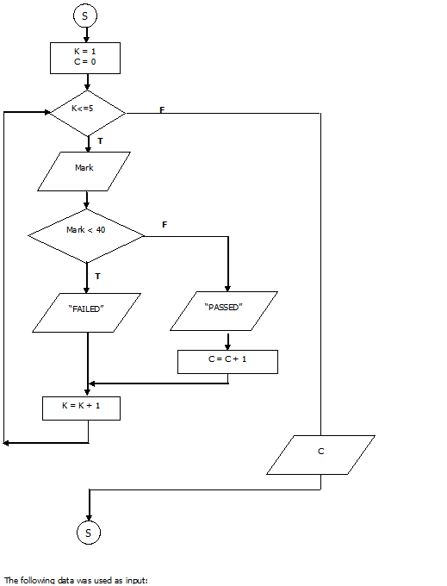

Draw a Trace Table for the above flowchart using the following data input:

30, 40, 70, 45, 65

Use the following format for your Trace Table:

K | C | K<=5 | Mark | Mark<40 | Output

(8)

4.2 The founders wish to treat the learners to a movie however they have the following criteria:

- Children under 10 cannot watch.
- Children between 10 and 13 need parental supervision
- Children older than 13 can watch on their own.

Create Pseudocode that can be used to design a program that asks for the child’s age and then determines whether the child can watch a movie based on the above criteria. (7)

4.3 You tell one of the learners that computers do processing using the Binary number system.

4.3.1 Explain what this system is. (2)

4.3.2 Show the learner how to convert 101101101₂ from binary to decimal. (5)

4.3.3 Show the learner how to convert 65431 from decimal to hexadecimal. (7)

QUESTION FIVE: INTERGRATED SCENARIO (19 MARKS)

The donated computers have to be networked so that information and the printer can be shared amongst
all the learners.

5.1 What is a network? (2)

5.2 List THREE reasons for having a network. (3)

5.3 Networks can be classified according to the distances covered. What type of network would be
most appropriate for connecting the computers at school. Give a reason for your answer. (2)

5.4 Communication media have specific strengths and weaknesses based on physical characteristics.
List FOUR weaknesses of communication media. (4)

5.5 This organization has sister branches in the following areas: Umthwalumi, Umlazi and Inanda.
The founders have decided to install a home/business satellite dish for Internet connection.
Give one advantage of having satellite connection. (2)

5.6 The security of the computers, network and data is important..

5.6.1. State TWO physical security measures that can be used protect the computers. (2)

5.6.2 State TWO actions that can be taken to prevent loss of data. (2)

5.7 What does Digital Divide refer to? Explain. (2)

TOTAL: 120

CONVERTED TOTAL: 120 / 4 X 5 = 150

